User Guide

Welcome to the Field Reservation App! This application is designed to streamline the process of reserving sports fields, catering to both customers and field managers.

Technologies Used

Frontend: Built with Flutter and Dart for a responsive and seamless user experience across both Android and iOS devices. Backend: Powered by Python Flask, ensuring a robust and secure server-side architecture. Features

For Customers: Field Reservation: Easily browse and reserve sports fields based on availability. Favorites: Add your preferred fields to a favorites list for quick access. Payment Management: Securely add and delete payment methods for seamless transactions. Reservation Status: Track the status of your reservations in real time.

For Field Managers: Field Management: Effortlessly add, edit, and delete field listings with all necessary details. Reservation Handling: Approve or deny customer reservations with just a few clicks. Reports: Access various reports to gain insights into field usage and reservations. Field Parameters: Update field details, including name and available reservation times.

Additional Features: Location Services: The app reads your current location and shows fields based on proximity. Google Maps Integration: Navigate to fields and explore the surrounding area using the fully embedded Google Maps. Google Sign-In: Easily sign in to your account using your Google credentials for a secure and streamlined experience.

1. Once the App Loads the user will have the option to allow access to the device's location or not

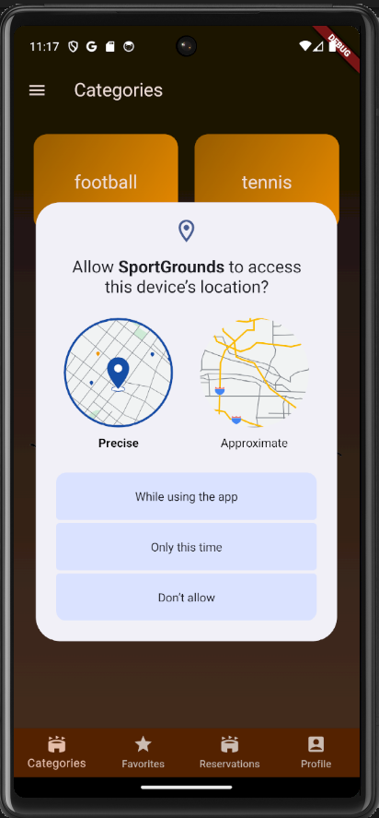

1. That is the Sign-In Page which can be accessed from the hamburger Bar on the top left, the Sign In includes encryption of the user's password, Or the user can choose to log in with Google (fully working Google Sign-In Integration)

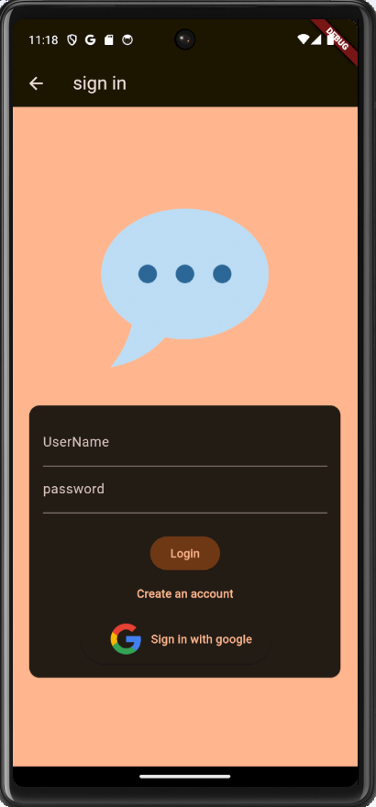

1. As you can see you can select already logged in accounts or add another account

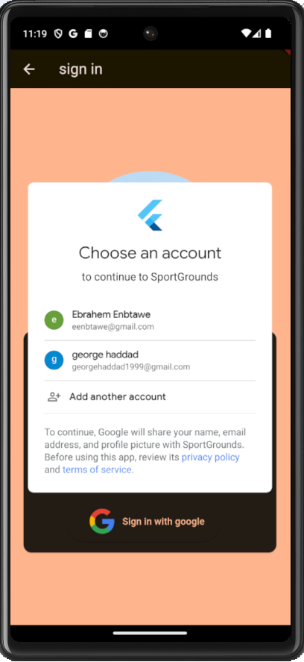

This is where the user chooses between the different Sports (Currently there is Football and tennis) You can also see the different tabs that the user can navigate to (Categories,Favorites,Reservations,Profile)

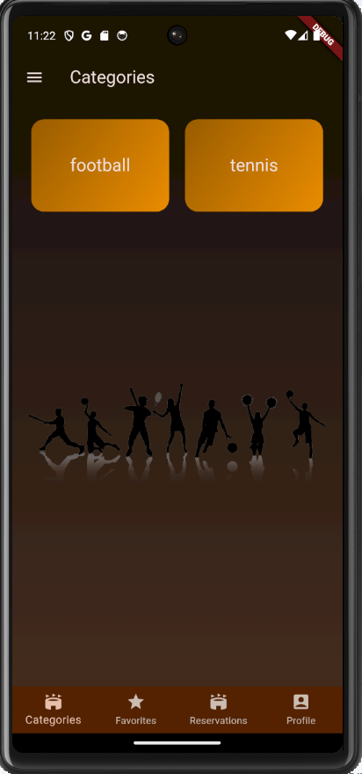

1. The user is presented with this page once he clicks one of the sport types (as you can see the fields are sorted according to the user's preferences and location (An Algorithm that is implemented in the back-end)

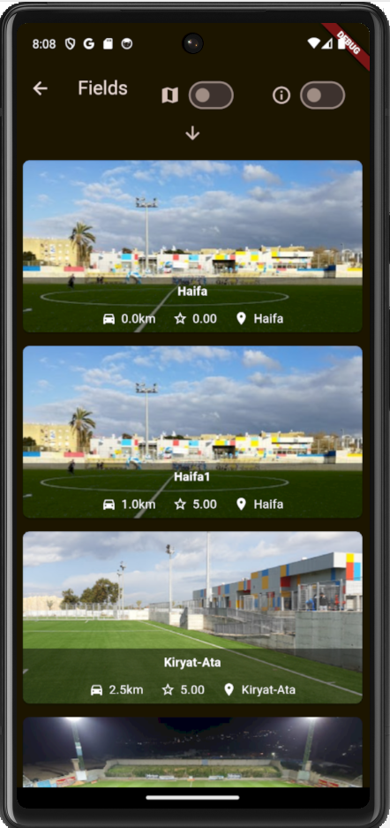

1. By enabling the top right button the user can access many filters

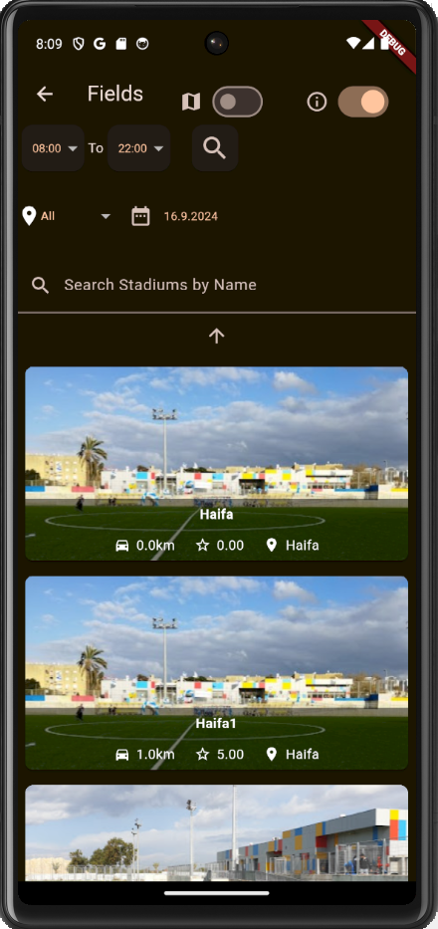

1. The user can also enable the MAP button which will display the different fields according to its location

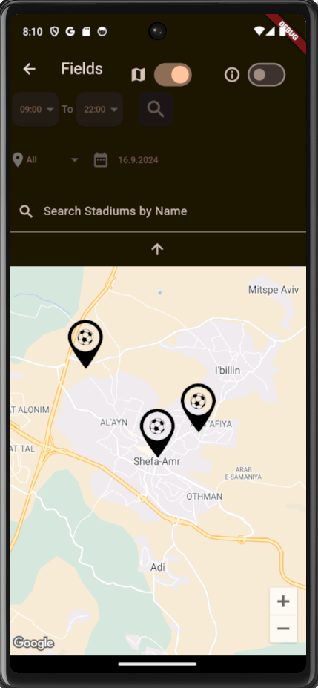

1. If the fields are tennis it will show different Icons on the MAP

1. After clicking the desired fields, the user will be presented with the following Page that includes details about the field and the Availability of the field itself The user can add the field to their Favorites as well by clicking the Star Icon found on the top right corner

* On the top page we see the field’s name, we can also see on the top right corner the favourites button
* The club utilities shows what does this stadium have.
* We can see the rating of the field
* We can see the location
* We can Navigate to the Field by clicking the Map Icon next to the “Navigate”
* And most importantly we can see the Availability of the field

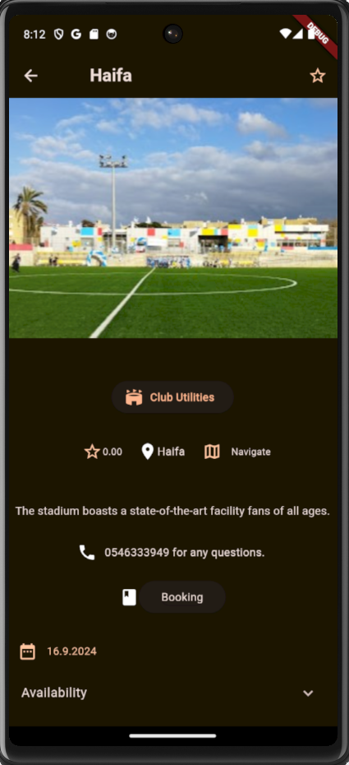

Club Utilities:   
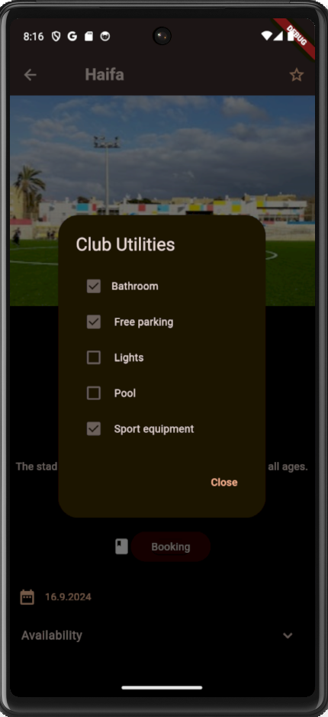

Navigation using google Maps:

1. The user can add the stadium to his Favorites, by clicking the Starr on the top right  
   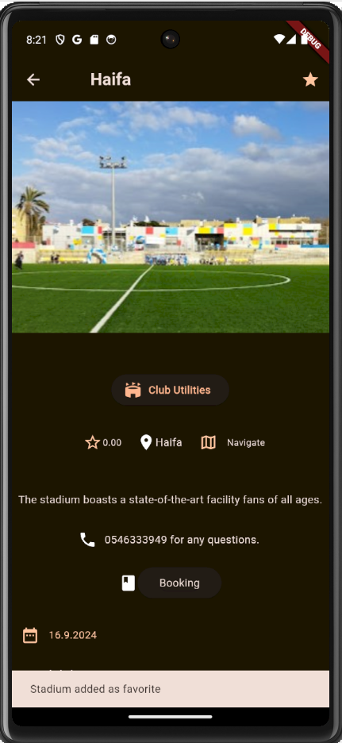
2. The user will see the stadium in his Favorites Tab   
     
     
   A screenshot of a phone

   Description automatically generated
3. The availability of the field. The user also can change the dates if the fields current date does not match his requirements  
     
     
   A screenshot of a phone

   Description automatically generated
4. Changing the date so the user can choose whatever dates that suits him   
     
   A screenshot of a cell phone

   Description automatically generated
5. After clicking one of the available times the user will be navigated to the checkout page where he will be presented with all the reservation details as well as his payment method he currently has, by clicking on the payment method he will be able to remove the current payment method and add another one.  
     
   A screenshot of a phone

   Description automatically generated
6. Adding Payment Method Page   
   A screenshot of a phone

   Description automatically generated
7. You can start booking fields once the payment method is validated   
     
   A screenshot of a phone

   Description automatically generated
8. After adding the payment method it is displayed in the Confirmation Page  
     
   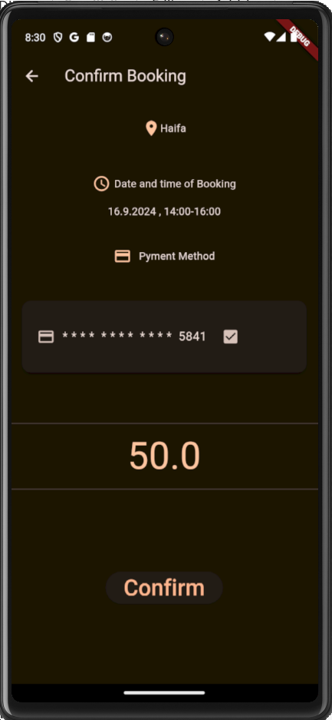
9. After clicking confirm the reservation will be booked and it will be in the Reservations in the pending section  
     
   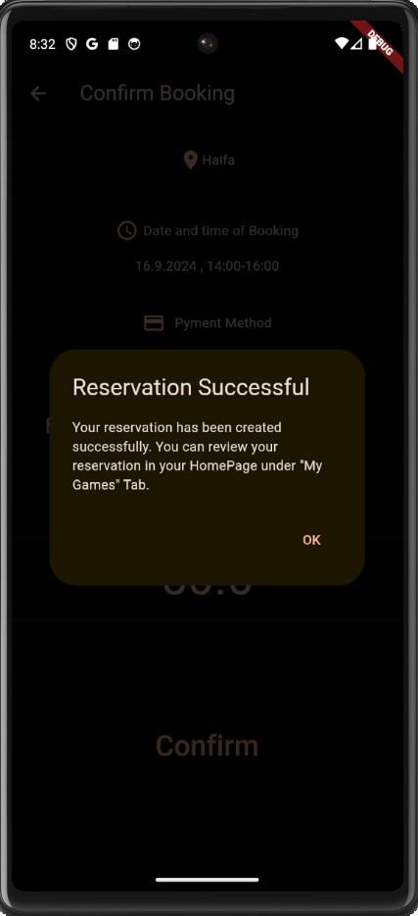
10. The Reservations Tab of the user shows the Pending/Cancelled/Accepted Reservations.  
    The manager that is responsible for this field will have to accept this reservation in order to be Accepted.   
      
    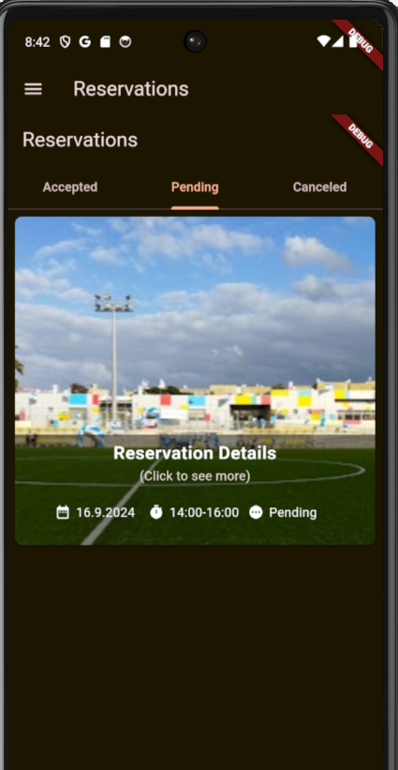  
      
      
      
      
      
      
      
      
      
      
      
      
      
      
      
    20. The user has the preference Tab in the Hamburger Bar, he can change what he prefers anytime he wants in order to get the best fields displayed for him ( this is done by using our algorithm that is implemented in the Back-End, that takes into consideration the user’s preferences)  
    A screenshot of a phone

    Description automatically generated
11. **Manager Side**  
      
    This is the Manager Side, we can see that the manager can view his fields, edit/delete, see his reservations, also statistics of his field.   
      
      
    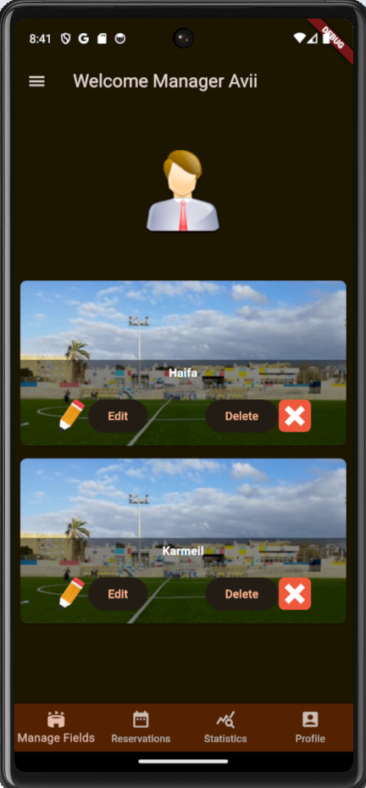
12. By Navigating to the Reservations Tab of the Manager we can see the reservation that we’ve shown in Figure(19) The manager decides whether to Accept or Decline   
      
    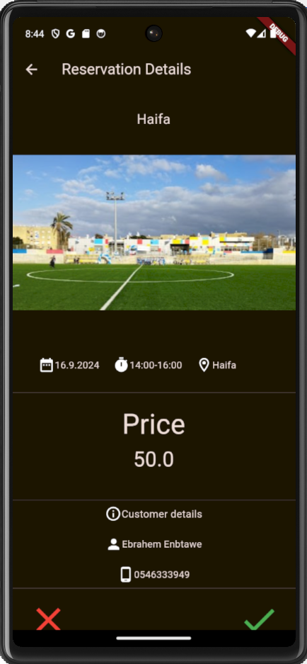
13. Lets Accept the reservation, navigating back to the customer’s side we can see that the reservation is now shown in the Accepted Tab:   
      
    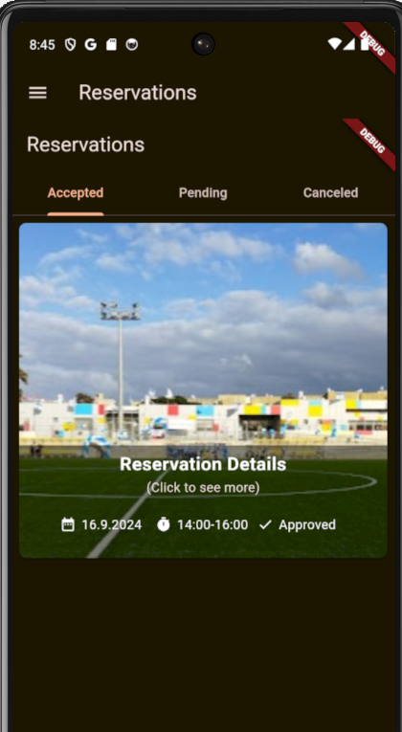
14. The Manager can edit Both the field Availability and Details:   
      
    A screen shot of a cell phone

    Description automatically generated

1. The manager can also Add a new field   
     
   A screenshot of a phone

   Description automatically generated
2. The manager can view his statistics in order to optimize his fields as much as possible, there is two kinds of reports, first one is amount of reservations per month:   
     
     
   A screenshot of a phone

   Description automatically generated

And this is amount of reservations by Hour:   
  
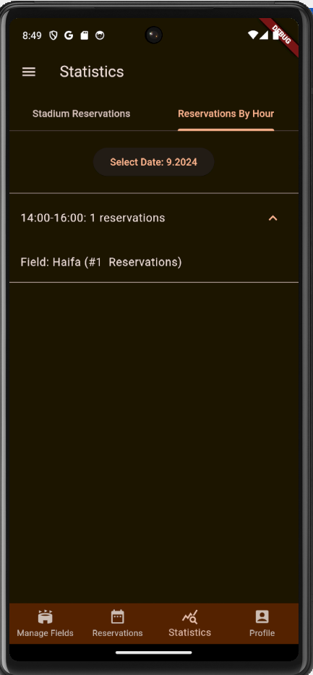  
  
  
  
This includes all the different capabilities of the Application, including Customer Side and Manager Side.